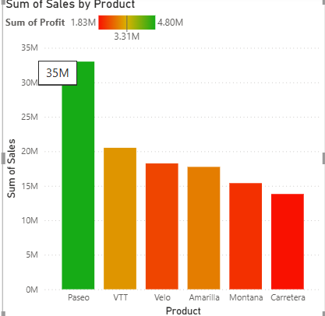

**Conditional formatting**

**SUM OF SALES BY PRODUCT**

STEPS :

VISUALIZATIONS -> VISUAL FORMAT

Click on strcked column chart

Columns;

Categories -> all

Color -> conditional formatting

Color -> categories -> format style -> gradient

What field should we base this on -> sum of profit

Summarization -> sum

How should we formet empty values -> Don’t format

Minimum -> lowest value , color – red

Center ->middle value , color – yellow

Maximum -> highest value ,color -> green

Click the add a middle color

Then click the ‘ OK ’ button..

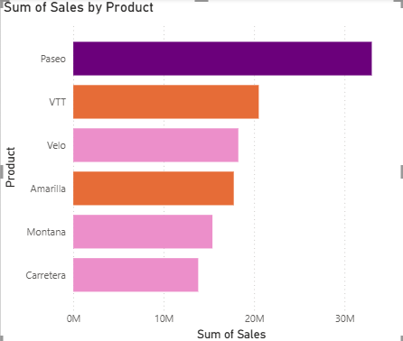

**Sum of sales by product**

**Steps :**

**1. Visualizations tab – format visual**

2. click on clustered bar chart

Build visual :

1. X – axis -> sales ( sum)
2. Y -> axis -> product

Format visual :

1. Format visual -> visual

BARS :

Categories :

Categories -> all

Color :

Color -> conditional formatting

Click on the conditional formatting

Color – categories

Format style -> Rules

What field should we base this on -> profit (sum)

Summarization -> sum

RULES :

IF VALUES - >=, **3500000** ( NUMBER) AND <= **5000000** ( NUMBER ) THEN COLOR -> THEME COLOR 4

IF VALUES - >=, **2500000** ( NUMBER) AND <= **3500000** ( NUMBER ) THEN COLOR -> ORANGE

IF VALUES - >=, **1500000** ( NUMBER) AND <= **2500000** ( NUMBER ) THEN COLOR -> PURPLE 40% LIGHTER

Then last click on the ‘ok’ button…

**Filter condition**

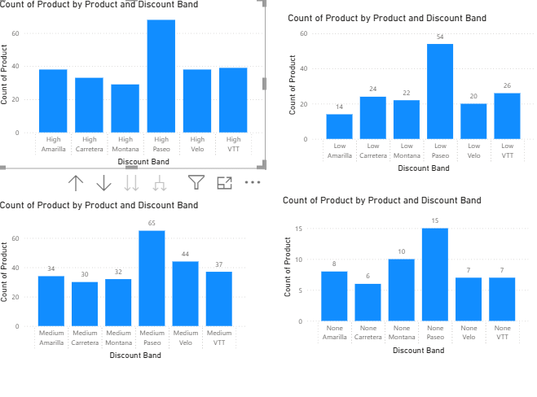

* **Steps :**
* Visualizations Tab :
  + Go to Build visual
  + Click on stacked column chart
* X- axis:

1). Product

2). Discount band

* Y- axis :

1). Count of product

* Filters :
* Filters on this visual – option
* Discount Band -> Is HIGH
* Discount Band -> Is LOW
* Discount Band -> Is MEDIUM
* Discount Band -> Is NONE
* Filter type :
* Basic filtering.

**Small Multiple :**

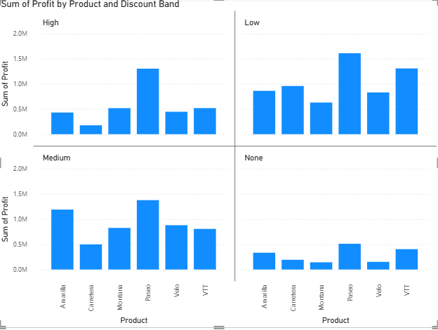

* **Steps :**
* Visualization Tab :
* Go to Build visual
* Click on stacked column chart
* X -axis :

1). Product

* Y -axis :

1).profit (sum)

* Small Multiple :
* Discount band
* Filters :
* Discount band -> All
* Filter type:
* Basic filtering.